Group: Henry Dinh, Peter Nguyen, Khanh Pham , John Zhao

Topic: Natural Disasters

Data Retrieval: We’ll be using Natural Disasters Dataset from ourworldindata.org and elsewhere.

Description: We’ll be performing several visual analyses on how the occurrence of one natural disaster can impact human life. We’ll be performing these analyses through the use of time series, bar charts, maps, etc…

Link: https://ourworldindata.org/natural-disastersData Visualization:

Example: Output

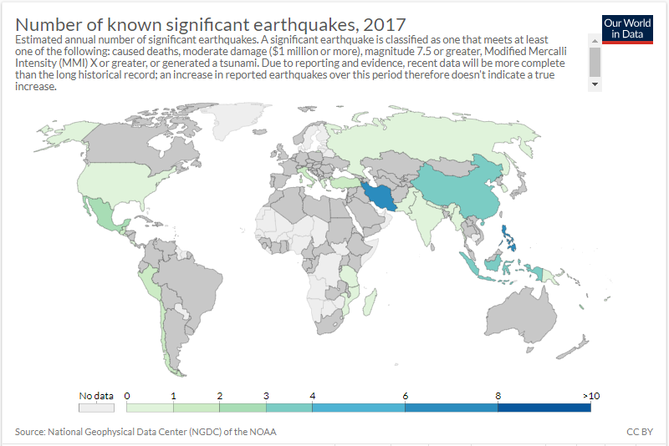 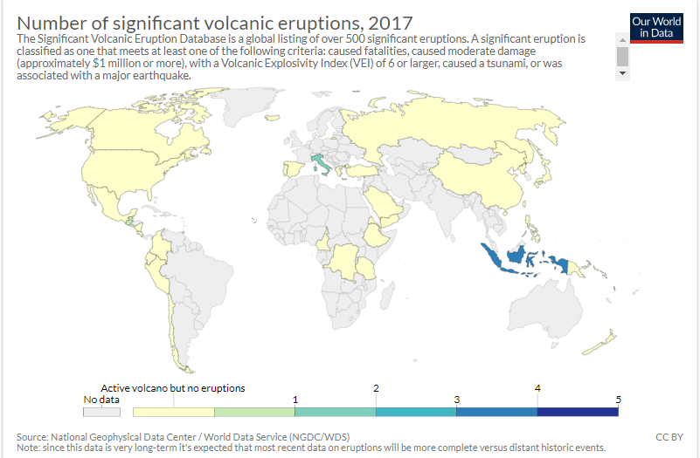

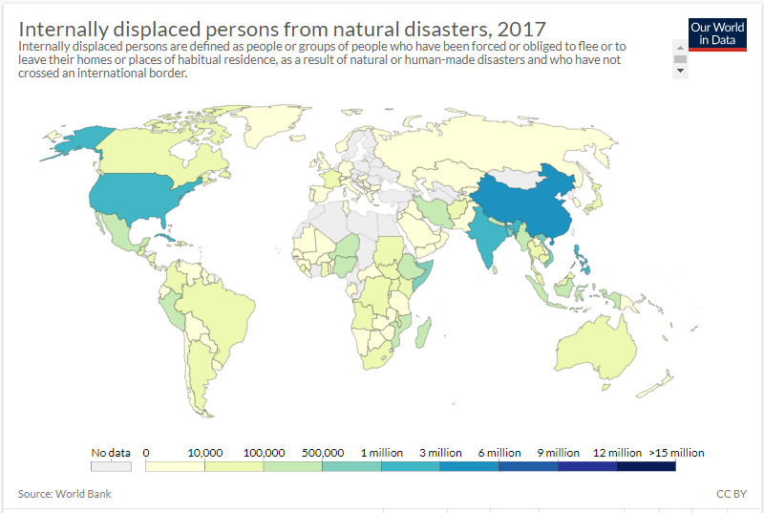 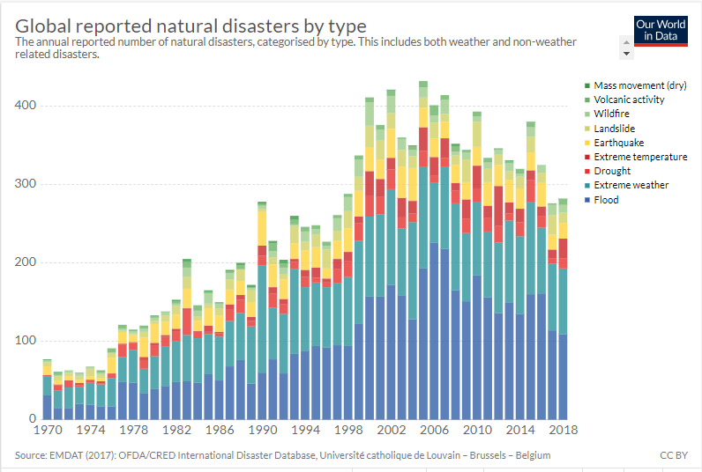

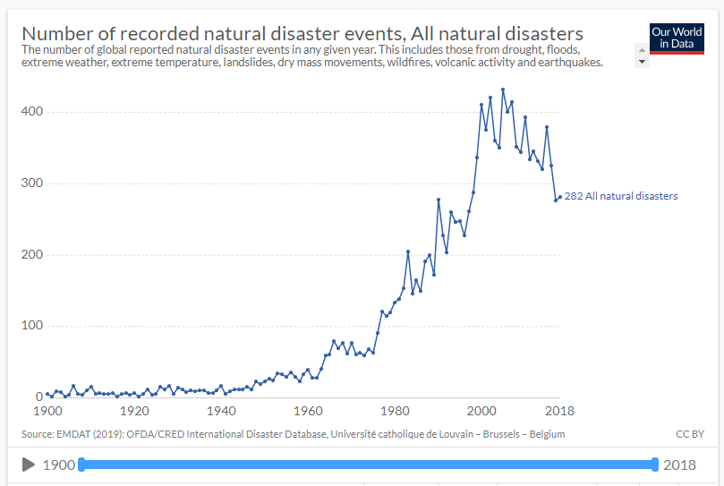

GitHub Link: <https://github.com/petersaur/ExamAnalysis>

First View:

Y Axis: Home/Injuries / Aff

X Axis: Year

Second View: Map – occurrence of each natural disaster and where it occurs. Also, when hovering we get a graph of how many affected are in that country.

Third View: TBD